**St.ANN’S COLLEGE OF ENGINEERING & TECHNOLOGY**

**DEPARTMENT OF ELECTRICAL AND ELECTRONICS ENGINEERING**

(Accredited twice by **NBA**, **IE(I)Kolkata**,**& NAAC** With “**A”** GRADE approved

by AICTE, NEWDELHI & Permanently AFFLIATED TO JNTUK)

**2010-2014**

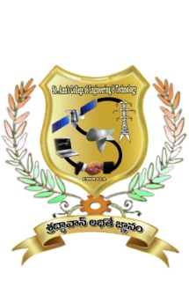

**CERTIFICATE**

This is to certify that the project work entitled **“A Novel Harmonic-Based Phase-Shifted Control to Regulate The Transferred Power”** thatis being submitted by **Mr._____________________________** bearing **Roll. No:** in partial fulfilment of the requirement for the award of the degree of **Bachelor of Technology in ELECTRICAL AND ELECTRONICS ENGINEERING** of **Jawaharlal Nehru Technological University Kakinada, Kakinada** isa record of bonafide work carried out by himunder my guidance and supervision during the academic year 2013-2014.

Viva voce date: --------------------

**Mr.S.V.D.ANIL KUMAR,M.Tech,(Ph.D)**

**Head of the Department**

**Mr.G.KALADHAR,M.Tech,(Ph.D)**

**Project Guide.**

**EXTERNAL EXAMINER**